PRIVATE & PERSONALIZED COACHING
w/Julie L Gibson-Vasquez
Life, Relationship, Family, Homeschool & Gifted Coach
Gifted, Sensitive & Creative Advocate & Mentor
“Offering Support to Adults & Children”

Perspectives Experience Approach

PROACTIVE PARENTING

“There are no bad children - only those with unmet needs or unresolved pain...”

Hello, my name is Julie Gibson-Vasquez. I am a gifted children advocate and mentor, the founder and organizer of RC Gifted Children Meetups & Parent Support and Homeschooling Support Meetup, a Life, Relationship, Homeschool, Family and Proactive Parenting Coach, who is passionate about supporting the special social, emotional and educational needs of gifted and or highly sensitive, highly creative and other "unique-needs" children (which probably includes all children ). I love supporting kids to gain a positive awareness of their unique and inherent strengths, gifts and talents, and to help them to identify their own goals, dreams and “super-power” — what they as unique individuals have to offer the world. I am concurrently passionate about supporting parents to identify, better understand and support their children's unique characteristics, emotions and needs.

I am also a parent of a gifted, highly sensitive & highly creative child who experienced severe emotional bullying in the public school system which resulted in an emotional breakdown at the age of 9. Sharing lessons learned and time-tested tools found along this journey of raising my daughter has turned into a passion for me. ﻿﻿﻿Gifted﻿﻿﻿ and or highly sensitive and highly creative children and their oftentimes concerned parents have become very important to me - they hold a special place in my heart and in my life. I have learned so much through raising my awesomely-unique daughter, and have loved having the opportunity to support other children and their parents through our Meetup groups. ​I am a certified Life Coach, currently in my 3rd year of training for my international certification in Life, Relationship and Parent Coaching. I am very excited to now have the opportunity to share my passion and support even further as a personal Life, Relationship, Homeschool, Family & Proactive Parenting Coach!

F​or Proactive-Parenting Coaching, my personal passion is in supporting kids to become all they were meant to be; identifying their strengths, providing information and tools to grow emotional intelligence and manage emotional and sensory sensitivities and intensities, and helping them to grow self esteem by creating a positive awareness of their natural and inherent modality, personal gifts and talents. I am also passionate about supporting parents to identify, understand, and support their unique children's needs better; to work towards improved communication, connection, learning, self esteem, internal motivation, self reliance and regulation, and more. Many of children's "negative behaviors" are reflective of unmet needs, misunderstood or misdirected positives, or the child's naturally inherent modality, communication and learning style not being understood and correctly utilized, things that educational and medical professionals are rarely trained to identify. Each child's strengths, as well as any struggles, need to be identified, understood and supported in order for them to reach their full potential. ​Through coaching and associated assessments I can help you to identify each of these things and learn how to best support your child

LIFE, RELATIONSHIPS & FAMILY
The Emotional Intelligence building life-skills I share through coaching, are some of the same things that allowed me to move past my own dysfunctional past, and the subsequent emotional pain, destructive behaviors and relationships of my teens, 20’s and early 30’s, toward real positive change in my life and relationships. I define Emotional Intelligence as simply, “The ability to understand our own, and others, emotions or feelings, and the actions or reactions that come from them.” The dictionary defines it as, “The capacity to be aware of, control, and express one's emotions, and to handle interpersonal relationships judiciously and empathetically.” Emotional Intelligence is now widely thought to be more important than IQ or intellectual intelligence in determining happiness and success in life. Being a gifted children advocate and mentor, a parent of an emotionally, imaginatively, creatively-gifted daughter, and witnessing their struggle as “unique-needs” kids, I wholeheartedly agree. By growing our Emotional Intelligence, we gain understanding, self-awareness, and new perspective, through which we learn humility and compassion, which can lead to real, actually amazing, change in our life and relationships. What I have learned through my own challenges and lessons learned in life, has allowed me at this point in my life to finally experience real peace; less anxiety and worry, less perfectionism, less arguing, less justifying, less blaming, less emotional pain...and to move forward toward a life free of the unhealthy patterns that had once controlled my life.

Those of you who know me well, know that I am a Christian, and that I believe the Bible has the greatest advice for living healthy lives and having healthy relationships, also that I have a confident and sure hope for a better world in the future where our lives and relationships will be perfect, forever. This knowledge gives me the greatest peace. I mention this because I know some wonder how psychology, or even life coaching, fits in with the other principals and beliefs they hold dear. Personally, I have found that basic psychology and coaching practices almost always align with the other truths and principals in my life. Since psychology and coaching today actually consists of a variety of perspectives and approaches, if you find something you are uncomfortable with, it is easy to just throw that one out and move on to another that works for you.

So, for me, It was through my own recovery and basic psychology that I found the answers to why I was struggling in my life and relationships. I found that when we grow up in a home where our needs are not met, or there is abuse or addiction, we will not be whole, healthy or fully functional in our life & relationships until we acknowledge the things we didn’t get in our childhood (perfect parents would provide and prepare us for life perfectly — today, no one is perfect), feel what we were not able or allowed to feel, and take care of the needs that were not met then, ourselves, as adults. Also, that by taking the time to heal and change ourselves, the cycle of dysfunction, abuse or addiction is broken, so that our children and their children...on and on, will not have the same personal struggles in life that we did. To me personally, this is a basic responsibility for all of us who have the opportunity — to get the help we need to provide for our family in the way that was intended, to give them the best chance at life. For me, it has been through basic psychology and coaching practices that I found the practical tools I was searching for that finally showed me the step by step methods to overcome my past, by putting these together with the other principals and values I hold dear, I am now able to live a healthier and happier life.

I grew up in a home with parents who loved me and took care of my basic physical needs, but who because of their own childhoods and past experiences could not model for me healthy relationships or life skills. What I have to share with others is a culmination of a life lived; making mistakes (a lot of them...a lot of them very dangerous mistakes), surviving to learn from them, and finally applying the lessons learned to my own life and relationships. Mistakes and negative experiences are the very things - if we are brave enough to identify, admit, not blame others, and learn from them - that create our Emotional Intelligence, allow us to move past the things that have held us back, and forward toward achieving the life and relationships we long for — this is the goal of Life Coaching — to help you identify and move past what holds you back, and provide you with new information, insight, life and coping skills and support, to move forward toward having the life and relationships you desire.

HOMESCHOOLING
As the organizer of two homeschooling Meetup and support groups, I have learned that families choose to homeschool for many different reasons. However, I have found that I often hear from young families of children soon to be school age, that the reason they are choosing to homeschool is because they feel their child just wouldn't fit in at a traditional school. Whether it was due to their child being highly energetic, or easily distracted unless doing something they loved, or highly sensitive and intense, or having unusual interests or a quirky personality that other kids just didn't seem to get, they thought these things would cause problems for their child, they were also worried that their child's uniqueness or unique behaviors would be mislabeled as some sort of behavioral, learning or psychological disorder. They didn't want their child to be labeled, or have to fight to make sure that didn't happen.

As the mother of an awesomely "out of the box" child myself, I understood their concerns. My daughter was once mislabeled by well meaning, yet misguided, family members and medical professionals. They saw my daughter's uniqueness or "misbehaviors" as indications of a behavioral problem or other disorder. I didn't agree. Knowing my daughter best, and after diligent personal study, I found that her behaviors were due to her inherently unique makeup; a highly Kinesthetic & Visual-Spatial learning style, high emotional and sensory sensitivities, and a highly creative and divergent mind. When these things were understood, correctly utilized and supported, they were no longer negatives. It became apparent to me that many of children’s "negative behaviors" are reflective of unmet needs, misunderstood or misdirected positives, or the child's naturally inherent modality, communication and learning style (things that educational and medical professionals are rarely trained to identify) not being supported. When each child's strengths, along with emotional and sensory sensitivities, intensities and other unique traits are identified, understood and supported, they are then able to move forward to reach their full potential.

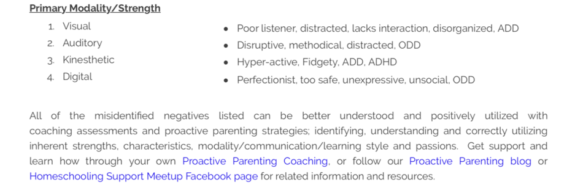
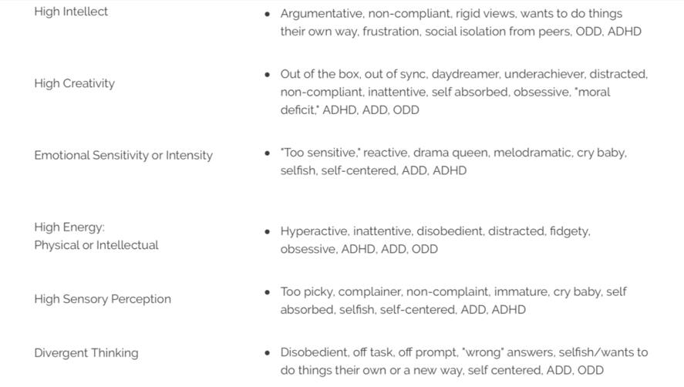
These days, many educational and medical professionals are quick to put a label on a child's behaviors. I am all for labels when the label indicates special needs, or a need for special support and accommodation for the child to develop optimally. I am not for negative labels, or mislabels, of a child's normal inherent characteristics, that with proper identification, understanding and utilization can actually be turned into positives. Of course, if after implementing new parenting and teaching strategies, sensory aids, and other proactive approaches, the child is still struggling, consultation with a medical professional should be considered. The following lists normal inherent characteristics found in children that are often mislabeled or misdiagnosed as disorder, however, with the right understanding and support can be turned into motivating and self esteem building positives.

REVIEWS

Julie L Gibson-Vasquez has a gift for understanding both the needs of children in all their marvelous diversity and the needs of their caregivers! — Peter 10 Jul , 2019

__________

​I can’t say enough great things about Julie. I met her providentially as I was seeking information regarding my son. I happened upon her meet up page on the internet, and after reading some of her articles, decided to give her a call. She was the first person I met who understood what I was going through. She was so kind and encouraging. A great listener. She encouraged me as a parent and shared helpful information with me. We also did some coaching sessions with her and it was very beneficial for both my son and I. She gave us tools to work through our personality differences and it helped our relationship greatly. Things have been so much better since applying what we have learned. We have definitely made great strides. I’m very grateful and would highly recommend Julie. ​ — Paula 06 May , 2019

__________

Julie is a loving and caring soul with decades of life experiences and intensive research into her field and her passion for helping and healing people. — Jim 05 Apr , 2019

__________

I recommend, very knowledgable. — Lindsey 05 Apr , 2019

__________

I personally have benefited so much from her Life and Parenting Coaching. She has helped me to better understand my own needs as well as the needs of (my son) and (my husband) as individuals with her Modalities Assessment along with other tools. She has shared with me helpful parenting techniques that ensure that (my son) feels understood while still addressing issues we encounter. I’m so thankful for her and all she has showed me. I feel like her Coaching is beneficial for everyone, especially when trying to better understand the ones you love and how to move through challenges in life effectively! — Shaylee 07 Sep , 2019

